Guideline of GLUE Program Installation and Running
Jianqiang He, Cheryl Porter, Paul Wilkens, Fabio Marin, Howard Hu, and James W. Jones
October 27, 2008

1. Overview
The GLUE (Generalized Likelihood Uncertainty Estimation) program is used to estimate genotype-specific coefficients for the DSSAT crop models. It is a Bayesian estimation method that uses Monte Carlo sampling from prior distributions of the coefficients and a Gaussian likelihood function to determine the best coefficients based on the data that are used in the estimation process. The GLUE program allows users to select a crop, then a cultivar to be estimated. The program will then identify all experiments and treatments in the DSSAT data files for the crop that have measurements for that cultivar. The user then can select one or more experiments and treatments that will actually be used in the coefficient estimation process. Another option for the user is to specify whether to estimate only those coefficients that control phenological development, only those that deal with expansive and dry matter growth, or both sets. Generally, one would want to estimate all parameters. What happens then is that the GLUE program will make 3,000 simulation runs for phenology coefficients and another 3,000 runs for growth coefficients. The program randomly generates parameters that are being estimated (either phenology or growth) from the prior distribution of parameter values and runs the model for each. The model outputs are used to select the parameter set with the maximum likelihood value based on comparison of simulated vs. observed variables, first for phenology parameters, then for growth parameters. The program also computes the uncertainties of the estimates (variances) for each parameter.

The maximum likelihood coefficients are written to a file in the same format as the cultivar file for the selected crop. These values can be copied into the CUL file (e.g., MZCER045.CUL or SBGRO045.CUL, etc.) to operate for routine DSSAT applications and further model evaluations.

What measurements are used to estimate the coefficients? For the development coefficients, measurements of first flower, physiological maturity, and first reproductive organ appearance dates are all used. For growth coefficients, final grain yield, above ground biomass, maximum leaf area during the season, final pod weight, final main stem leaf number, and unit grain weight are used. Thus, the measurements that go into File – A in DSSAT are used; these are variables measured only one time during the season, most of which were measured at harvest.

There are several assumptions that may have important effects on the resulting parameters. First are the prior distributions of coefficients, which are stored in a file called ParameterProperty.xls. This file has information for all of the DSSAT v4.5 crops. We assumed that the parameters have uniform distributions with minimum and maximum values. This is a conservative assumption, and values are provided in the files based on previous work with the models. A second assumption is that the final errors between simulated and observed values are normally distributed and are unbiased. The assumed values of the variances are given in a file named MeasurementVariances.xls. This assumption may be a problem, particularly if the model is not able to describe responses for a particular experiment very well or if observations are not reliable. Another problem will occur if the experiment had water, nutrient, or other stresses that are either not in the model or that the model does not represent well. Users should only use treatments that are near stress-free conditions, if possible, to minimize these problems. Coefficients estimated using treatments with moderate to severe stress effects will not be reliable. In any case, users should carefully check results from any estimation process to make sure that results are realistic and provide good comparisons to observations used in estimation.

There are other cautions that users should be aware of. For example, results from an estimation process provide conditional estimates of coefficients. That means that the coefficients are the best set given the measurements that were used, but the coefficients also depend on the set of observations used in the process. Our aim is for the coefficients to be robust and useful across environments, but this may not be the case. Another caution is that coefficients estimated from end of season measurements may not reproduce observed time series results very well if such measurements were made. We have seen this occur in various experiments when only end of season measurements are used, whether using GLUE or other estimation procedures. If users have time series data, these data can be used manually to refine the coefficients estimated from the GLUE procedure. It is possible to use in-season measurements and simulations in this type of Bayesian estimation process, but there are certain complications that make it difficult to create a robust and reliable automated procedure.

The GLUE program is one of two tools in DSSAT for estimating cultivar coefficients for the different crops. The first tool, developed by L. A. Hunt and others, evolved from the GENCALC software available in DSSAT v3.5. There are advantages and disadvantages of using each. Disadvantages of the GLUE technique is that it may require a lot of time for the computations, depending on the number of treatments selected for the estimation process. If there are only 2-5 measurement data sets, one would expect the GLUE procedure to finish its calculations in less than 2 hours. However, if there are many measurement data sets, say more than 15, the GLUE method will likely require several hours of calculations. This is a practical limit. On the other hand, the GLUE method can be used, without intervention by users, to produce a set of estimated coefficients. It also provides estimates of the uncertainties of the parameters. This method does not depend on heuristic rules, making it simple to implement for additional crops as they are added to DSSAT.

2. Installation of the GLUE Programs
The GLUE program was developed using the R statistical programming language. So, you should have it installed on your computer before you go further. The DSSAT installation disk has an option to install R, as shown below. You should select the “Install R” button so that R will be available for use in estimating genetic coefficients using the GLUE program.
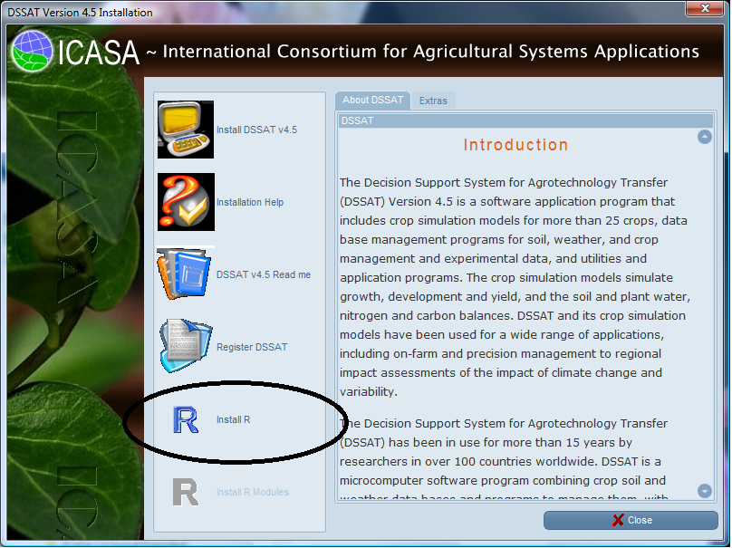
Figure 1. Installation screen of DSSAT.

After installing R version 2.10.1 in your machine (from the DSSAT installation disk as shown above), you should configure R to be used with GLUE. The R program requires two packages, “MASS” and “xlsReadWrite”, to run the GLUE program. To install them, follow these steps:

C:\PROGRA~1\R\R-210~1.1\bin\RTerm --slave < C:\DSSAT45\Tools\GLUE\Glue.r

Installing the R packages “MASS” and “xlsReadWrite”
- Run R with Administrator privileges in sessions where you want to install packages. Do so by right-clicking on the R shortcut and selecting 'Run as Administrator'.
- Using the File pull-down menu on R, Select “change dir…” and browse to the DSSAT45/Tools/GLUE/Install directory. Hit “OK” to close the window (Figure 2).
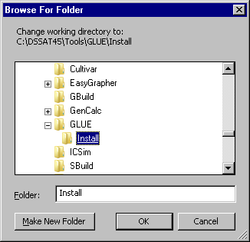
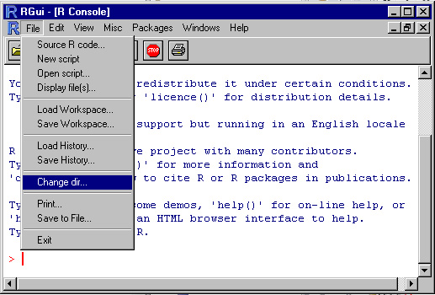
Figure 2. R File pull-down menu screen.

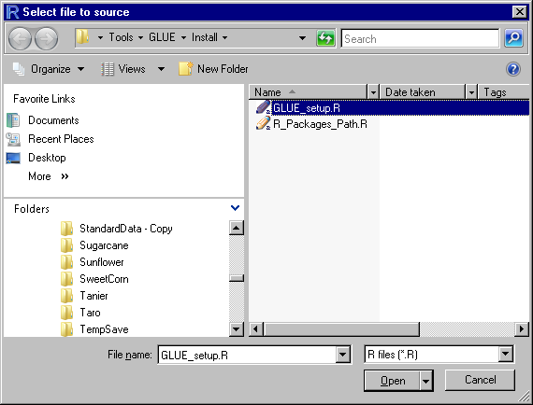
- Using the File pull-down menu on R, Select “Source R code…” and select GLUE_setup.R and then hit “Open”. By selecting this file, both packages needed for GLUE (“MASS” and “xlsReadWrite”) will be installed (Figure 3). 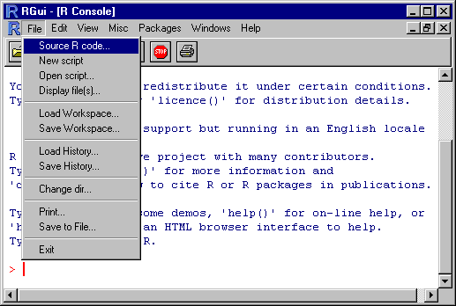

Figure 3. R package selection screen.

- A message will show up in the command space to show you the package has been successfully installed. The package R_packages_path.r does not need to be installed (Figure 4).
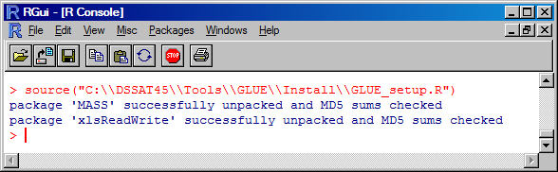
Figure 4. R message on the package installation process.

- You can close R and go back to DSSAT.

3. Use of the GLUE Procedure to Estimate Genetic Coefficients
3.1 Setting conditions for GLUE to estimate coefficients
The GlueSelect program was written by Paul Wilkens (IFDC) as a tool in DSSAT v4.5. This tool uses much of the code that he and L. A. Hunt developed for GenSelect, which is a rule-based estimator of cultivar coefficients. Currently, the GLUE program operates on most crops (except those legacy crops that are not converted to v4.5 standards). However, we are more confident of the program correctly estimating cultivar coefficients for the following crops: maize, soybean, peanut, millet, sorghum, chickpea, cotton, fababean, sweet corn, tomato, green beans, rice, wheat, and drybean. Users should check the coefficients carefully before using them. This can be done by putting the estimated parameters in the appropriate CUL file and simulating the crop interactively for comparison with observed data.

The file that has definitions of genetic coefficients and their ranges of uncertainty for all crops is “ParameterProperty.xls” (see Appendix A for details), and “MeasurementVariance.xls” (see Appendix B). These files are stored in the directory “C:\DSSAT45\Tools\GLUE\”. Advanced model users can modify them to set other ranges of parameters, change parameters to be estimated, introduce parameters for new crops, and change the order in which they are estimated.

The GLUE program is integrated into the DSSAT45 shell, and the user runs the GlueSelect program from the DSSAT Tools menu to start the process (Figure 5).
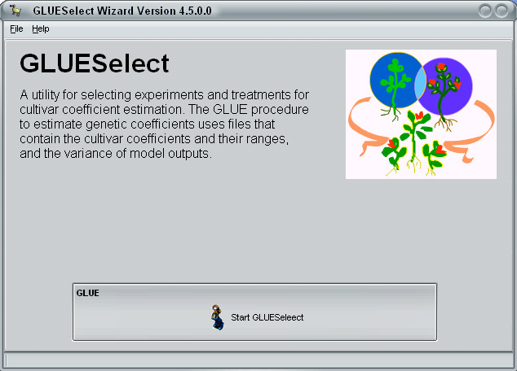
Figure 5. Initial screen when GLUESelect program is run.

The second GlueSelect screen shows all of the crops. A user selects a crop, such as peanut as shown in Figure 6, and then a particular cultivar that is to be estimated (“FLORUNNER, std” in Figure 6). After selecting “Go” on this screen, a list of experiments and treatments will appear (Figure 7). In this figure, three growing seasons were selected from three different years and experiments. These treatments will be simulated, using the Monte Carlo method to estimate the coefficients that give the maximum likelihood for both phenology and growth measurements.

The third GlueSelect screen shows the console for operating the actual GLUE calculations and viewing the results. Figure 8 shows, for example, that there are to be 3,000 runs for all parameters, which means that there will be 3,000 runs for phenology parameters and another 3,000 for growth parameters. This number can be changed to a few, say 10, to make sure that the program is operating ok. However, results from runs less than 3,000 would not likely give reliable results. So, if the number is changed from 3,000 to test the procedure, then it must be changed back to 3,000 (or more) in order to get reliable results. It is ok to increase this number to further refine the results, but more time will be required if this is done.
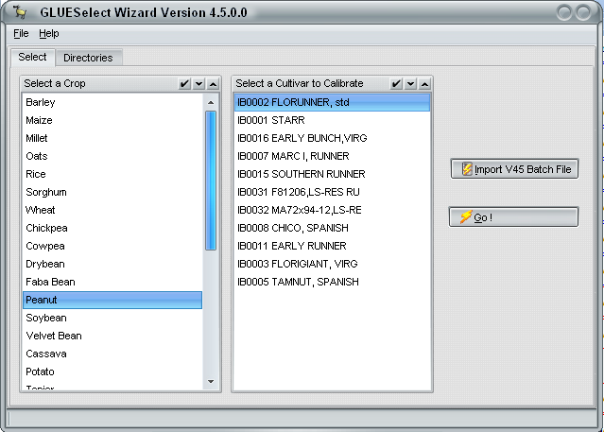
Figure 6. GlueSelect screen for selecting the crop and cultivar showing selection of peanut and FLORUNNER,std cultivar.

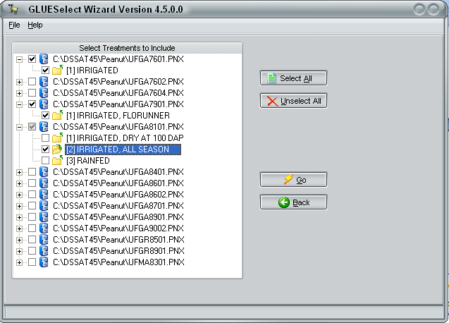
Figure 7. GlueSelect screen showing selection of 3 specific treatments (in three experiments) for use in estimating cultivar coefficients for the previously selected cultivar – FLORUNNER,std.

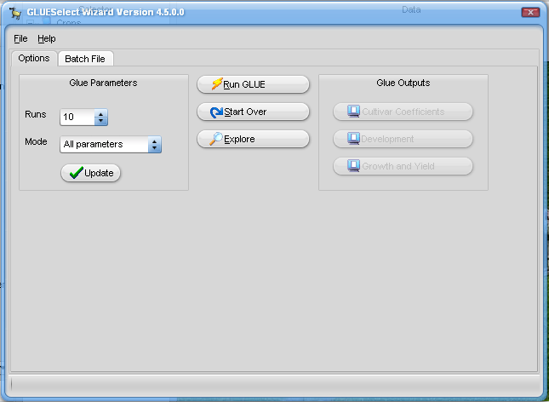
Figure 8. Screen shot showing which coefficients to estimate, how many runs to make, running the program, and viewing the outputs.

3.2. Running GLUE

Figure 9 also shows how users initiate the simulation runs to estimate the coefficients – “Run GLUE”. One could also start over, as indicated. Before running GLUE, however, you may want to “Disable On-Access Scan) of your virus software. Our experience is that the system will operate much faster by doing this before running GLUE, as much as 5 or more times faster. GLUE runs may take some time, possibly from 0.5 to 2 hours for example, depending on how many seasons are selected for estimating the coefficients.

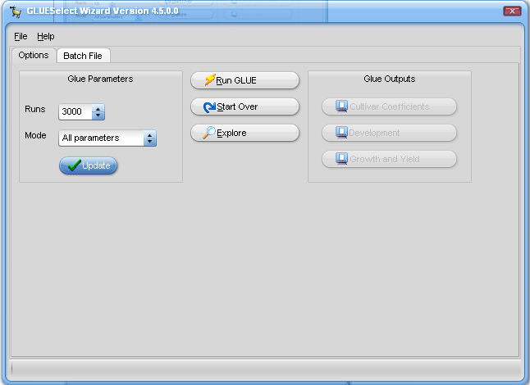
Figure 9. Main screen in GLUE for running the coefficient estimation process (circled) and also for viewing outputs. From this screen, one can view the final estimated coefficients and copy them to put into the appropriate cultivar file (.CUL in the DSSAT45\Genetics directory) and also to review statistics (mean, maximum likelihood, and standard deviation of the estimated coefficients.

3.3 GLUE Results

The main results that users will be interested in can be seen by selecting the “View Cultivar Coefficient” button (Figure 10). This will open an editor with the final values of the estimated coefficients in it. The format of the file is the same as the CUL file for the selected crop, so one can copy this new set of cultivar coefficients into the appropriate CUL file to use in additional simulations. Note that one should use the DSSAT feature to “Update all Lists” after adding a new cultivar to any CUL file.

All of the outputs of DSSAT and GLUE running are saved in the “C:\DSSAT45\GLWork\” directory. The contents of main output files are briefly described as follows:

- Optimal Parameters. The optimal parameter set that was chosen through GLUE procedure was saved as a “CUL” file named according to the name and ID of the selected cultivar when generating the batch file. For example, if the selected cultivar was soybean “COBB”, then the “CUL” file is “SBIB0002 COBB.CUL” (Table 1 in Appendix E).
- Statistics of Posterior Distributions (Mean, Standard Deviation, and Maximum Likelihood Values). The two files identified as “PosteriorDistribution_1.txt” and “PosteriorDistribution_2.txt” (Table 2 and 3 in Appendix E) store the posterior distributions for each round of GLUE, including the mean values, standard deviations, and the parameter set that has the highest likelihood value in that round of GLUE.
- Empirical Distribution of Parameter Tables. The two files identified as “RandomParameterSetsAndProbability_1.txt” and “RandomParameterSetsAnd
Probability_2.txt” (Table 4 and 5, Appendix E) store the really used parameter sets and their corresponding probability or normalized likelihood values for each round of GLUE.
- Generated Parameter Sets. The two files identified as “RealRandomSets_1.txt” and “RealRandomSets_2.txt” store the really used parameter set in each round of GLUE.
- Last Model Run Results. “Evaluate_output.txt” stores the content of output file “Evaluate.OUT” of DSSAT for each model run. Since the “Evaluate_output.txt” is processed after each model run, only the result of last model run will be available in the “Evaluate_output.txt” file after the GLUE procedure. This file is not needed for result analysis, but it is described here because it will be in the directory and model users should ignore it.
- Results for Computing Likelihood Values. The two files “EvaluateFrame_1.txt” and “EvaluateFrame_2.txt” store the appended data of the processed “Evaluate_output.txt” files for the two rounds of GLUE. In each file, the simulated and measured outputs are saved for each treatment and each model run.
- Combined Likelihood Value for Each Parameter Set. The two files identified as “IntegratedLikelihoodMatrix_Frame_1.txt”, and “IntegratedLikelihoodMatrix_Frame_2.txt” (not shown) store the combined likelihood values for all treatments in each model run or for reach parameter set. For example, in the file “IntegratedLikelihoodMatrix_Frame_1.txt”, it stores the combined likelihood values for observations “ADAP”, “MDAP”, and “PD1P” for the first round GLUE. In “IntegratedLikelihoodMatrix_Frame_2.txt”, it stores the combined likelihood values for observations “PWAM”, “HWAM”, “CWAM”, “LAIX”, and “L#SM” for the second round GLUE. When the combined likelihood value is “1” in one column, it means the observation is absent.
- Combined Likelihood Value for Each Experiment Treatment. If there are only two treatments in the experiment for GLUE procedure, then the following files, “IntegratedLikelihoodTreatment_1_1.txt”, “IntegratedLikelihoodTreatment_1_2.txt”, “IntegratedLikelihoodTreatment_2_1.txt”, and “IntegratedLikelihoodTreatment_2_2.txt”, respectively, store the combined likelihood values for each treatment in each round of GLUE. The “IntegratedLikelihoodTreatment_1_1.txt” file, for example, stores the combined likelihood value for GLUE 1 and treatment 1 for all generated parameter sets, so do other files. One can see these files in the DSSAT45/GLWork directory after any GLUE estimation procedure is run.
3. How to Add a New Crop
When a new crop is added to DSSAT, cultivar coefficients for this crop can also be estimated after adding appropriate information in the ParameterProperty.xls file if the naming conventions for measurements and simulated outputs are standardized and the same as for other crops. However, if headers are different for a new crop, then additional information must be added to MeasurementVariances.xls file. The MeasurementVariance.xls file shows how additional sheets in the spreadsheet must be set up for the crop.

Appendices
Appendix A
Example Genotype Parameters and Ranges from ParameterProperty.xls File for Maize and Soybean

 | Minimum | Maximum | Flag¹
MZ | 6 | 6 | 6
MZ_P1 | 5 | 450 | 1
MZ_P2 | 0 | 2 | 1
MZ_P5 | 580 | 999 | 1
MZ_G2 | 248 | 990 | 2
MZ_G3 | 5 | 16.5 | 2
MZ_PHINT | 49 | 49 | 0
SB | 18 | 18 | 18
SB_CSDL | 11.78 | 14.6 | 0
SB_PPSEN | 0.100 | 0.385 | 1
SB_EM.FL | 9 | 23.5 | 1
SB_FL.SH | 10 | 10 | 0
SB_FL.SD | 12 | 16 | 1
SB_SD.PM | 29 | 37.7 | 1
SB_FL.LF | 18 | 18 | 0
SB_LFMAX | 0.95 | 1.15 | 2
SB_SLAVR | 300 | 400 | 2
SB_SIZLF | 140 | 230 | 2
SB_XFRT | 1 | 1 | 0
SB_WTPSD | 0.158 | 0.195 | 2
SB_SFDUR | 17 | 25.5 | 2
SB_SDPDV | 1.7 | 2.44 | 2
SB_PODUR | 10 | 10 | 0
SB_THRSH | 78 | 78 | 0
SB_SDPRO | 0.4 | 0.4 | 0
SB_SDLIP | 0.2 | 0.2 | 0
¹The FLAG column indicates which coefficients are to be estimated using phenology measurements (FLAG=1), which are to be estimated using growth measurements (FLAG=2) and which coefficients are not to be estimated (FLAG=0).

Appendix B
Variances of Observations for Most Crops
 | STD | Variance | CV | Flag | Description
ADAP | 3 | 9 |  | 1 | Anthesis day (dap).
MDAP | 7 | 49 |  | 1 | Physiological maturity day (dap).
PD1T | 4 | 16 |  | 1 | First pod date (YrDoy).
PWAM |  |  | 0.3 | 2 | Pod/Ear/Panicle weight at maturity (kg [dm]/ha).
HWAM |  |  | 0.3 | 2 | Yield at harvest maturity (kg [dm]/ha).
CWAM |  |  | 0.3 | 2 | Tops weight at maturity (kg [dm]/ha).
LAIX |  |  | 0.4 | 2 | Leaf area index, maximum.
HWUM |  |  | 0.1 | 2 | Grain unit weight at maturity (g/seed)
L.SM | 3 | 9 |  | 2 | Leaf number per stem at maturity. The symbol "#" was changed to ".", since it is the symbol of comments in R.

Appendix C
Batch File “COBB.SBC” Created with GLUESelect

$BATCH(CULTIVAR):SBIB0002 COBB

@FILEX TRTNO RP SQ OP CO
C:\DSSAT45\Soybean\UFGA8101.SBX 1 0 0 0 0
C:\DSSAT45\Soybean\UFGA8501.SBX 1 0 0 0 0

Appendix D
Batch File “GLUE.BAT”

C:\Progra~1\R\R-2.10.1\bin\Rterm --slave < C:\DSSAT45\Tools\GLUE\GLUE.r

Appendix E
Output Files of GLUE Procedure

1. Optimal parameter set saved as a CUL file (SBIB0002 COBB.CUL)
IB0002 COBB (8) . SB0801 12.54 0.373 23.83 9.200 20.11 32.63 18.00 1.090 346.0 162.7 1.000 0.184 17.16 1.846 10.00 78.00 0.400 0.200

2. Posterior distribution in first round GLUE (PosteriorDistribution_1.csv)
Param | SB_CSDL | SB_PPSEN | SB_EM.FL | SB_FL.SH | SB_FL.SD | SB_SD.PM | SB_FL.LF | SB_LFMAX | SB_SLAVR | SB_SIZLF | SB_XFRT | SB_WTPSD | SB_SFDUR | SB_SDPDV | SB_PODUR | SB_THRSH | SB_SDPRO | SB_SDLIP
Mean | 12.174 | 0.303 | 23.286 | 9.2 | 18.558 | 31.511 | 18 | 1.03 | 375 | 190 | 1 | 0.158 | 23 | 1.9 | 10 | 78 | 0.4 | 0.2
STDEV | 0.327 | 0.073 | 3.602 | 0 | 2.587 | 2.99 | 0 | 0 | 0 | 0 | 0 | 0 | 0 | 0 | 0 | 0 | 0 | 0
MaxProbability | 12.538 | 0.373 | 23.831 | 9.2 | 20.113 | 32.635 | 18 | 1.03 | 375 | 190 | 1 | 0.158 | 23 | 1.9 | 10 | 78 | 0.4 | 0.2

3. Posterior distribution in second round GLUE (PosteriorDistribution_2.csv)
Param | SB_CSDL | SB_PPSEN | SB_EM.FL | SB_FL.SH | SB_FL.SD | SB_SD.PM | SB_FL.LF | SB_LFMAX | SB_SLAVR | SB_SIZLF | SB_XFRT | SB_WTPSD | SB_SFDUR | SB_SDPDV | SB_PODUR | SB_THRSH | SB_SDPRO | SB_SDLIP
Mean | 12.538 | 0.373 | 23.831 | 9.2 | 20.113 | 32.635 | 18 | 1.187 | 345.327 | 178.795 | 1 | 0.184 | 18.651 | 2.042 | 10 | 78 | 0.4 | 0.2
STDEV | 0 | 0 | 0 | 0 | 0 | 0 | 0 | 0.105 | 25.85 | 27.183 | 0 | 0.008 | 1.324 | 0.22 | 0 | 0 | 0 | 0
MaxProbability | 12.538 | 0.373 | 23.831 | 9.2 | 20.113 | 32.635 | 18 | 1.09 | 346.041 | 162.69 | 1 | 0.184 | 17.165 | 1.846 | 10 | 78 | 0.4 | 0.2

4. Example random parameter sets and their Likelihood values and in first round GLUE (RandomParameterSetsAndProbability_1.txt)
CSDL | PPSEN | EM.FL | FL.SH | FL.SD | SD.PM | FL.LF | LFMAX | SLAVR | SIZLF | XFRT | WTPSD | SFDUR | SDPDV | PODUR | THRSH | SDPRO | SDLIP | Probability
12.538 | 0.373 | 23.831 | 9.200 | 20.113 | 32.635 | 18.000 | 1.030 | 375.000 | 190.000 | 1.000 | 0.158 | 23.000 | 1.900 | 10.000 | 78.000 | 0.400 | 0.200 | 0.227
12.549 | 0.364 | 26.064 | 9.200 | 21.883 | 29.549 | 18.000 | 1.030 | 375.000 | 190.000 | 1.000 | 0.158 | 23.000 | 1.900 | 10.000 | 78.000 | 0.400 | 0.200 | 0.117
11.791 | 0.200 | 26.731 | 9.200 | 15.802 | 34.909 | 18.000 | 1.030 | 375.000 | 190.000 | 1.000 | 0.158 | 23.000 | 1.900 | 10.000 | 78.000 | 0.400 | 0.200 | 0.115
11.895 | 0.187 | 27.931 | 9.200 | 16.092 | 34.792 | 18.000 | 1.030 | 375.000 | 190.000 | 1.000 | 0.158 | 23.000 | 1.900 | 10.000 | 78.000 | 0.400 | 0.200 | 0.103
11.784 | 0.262 | 21.206 | 9.200 | 13.915 | 29.413 | 18.000 | 1.030 | 375.000 | 190.000 | 1.000 | 0.158 | 23.000 | 1.900 | 10.000 | 78.000 | 0.400 | 0.200 | 0.095
12.339 | 0.376 | 19.642 | 9.200 | 19.395 | 28.400 | 18.000 | 1.030 | 375.000 | 190.000 | 1.000 | 0.158 | 23.000 | 1.900 | 10.000 | 78.000 | 0.400 | 0.200 | 0.085

5. Example random parameter sets and their Likelihood values and in second round GLUE (RandomParameterSetsAndProbability_2.txt)
CSDL | PPSEN | EM.FL | FL.SH | FL.SD | SD.PM | FL.LF | LFMAX | SLAVR | SIZLF | XFRT | WTPSD | SFDUR | SDPDV | PODUR | THRSH | SDPRO | SDLIP | Probability
12.538 | 0.373 | 23.831 | 9.200 | 20.113 | 32.635 | 18.000 | 1.090 | 346.041 | 162.690 | 1.000 | 0.184 | 17.165 | 1.846 | 10.000 | 78.000 | 0.400 | 0.200 | 0.016
12.538 | 0.373 | 23.831 | 9.200 | 20.113 | 32.635 | 18.000 | 1.029 | 342.632 | 189.759 | 1.000 | 0.186 | 17.602 | 1.775 | 10.000 | 78.000 | 0.400 | 0.200 | 0.015
12.538 | 0.373 | 23.831 | 9.200 | 20.113 | 32.635 | 18.000 | 1.110 | 330.573 | 174.342 | 1.000 | 0.186 | 17.317 | 2.364 | 10.000 | 78.000 | 0.400 | 0.200 | 0.015
12.538 | 0.373 | 23.831 | 9.200 | 20.113 | 32.635 | 18.000 | 1.011 | 307.951 | 203.991 | 1.000 | 0.190 | 17.585 | 2.005 | 10.000 | 78.000 | 0.400 | 0.200 | 0.015
12.538 | 0.373 | 23.831 | 9.200 | 20.113 | 32.635 | 18.000 | 1.082 | 339.885 | 225.893 | 1.000 | 0.194 | 18.123 | 1.792 | 10.000 | 78.000 | 0.400 | 0.200 | 0.015
12.538 | 0.373 | 23.831 | 9.200 | 20.113 | 32.635 | 18.000 | 1.150 | 375.298 | 163.908 | 1.000 | 0.191 | 17.539 | 1.719 | 10.000 | 78.000 | 0.400 | 0.200 | 0.014

